**Assignment 17.3**

**Problem Statement:**

Write a mapreduce job that takes configuration from command line (min.word.count). Based on the configuration, it should perform count of words from a document and produce only those words in the output whose count is greater than or equal to the configuration.

**Input:**

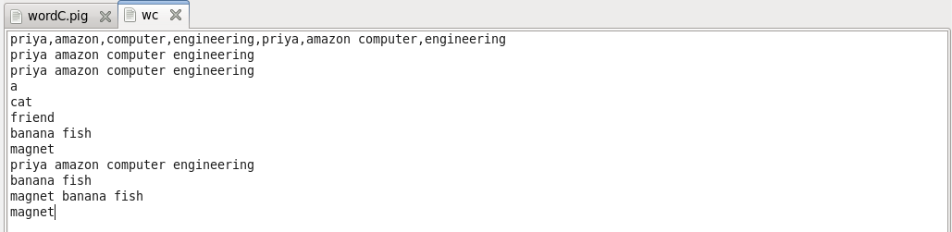

**Program:**

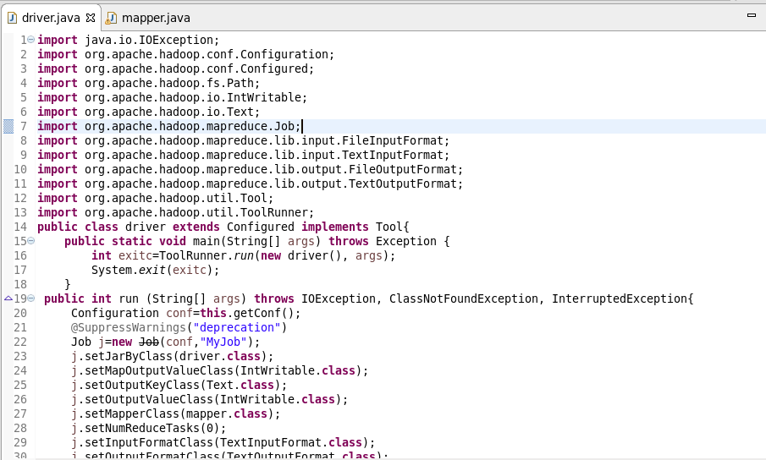

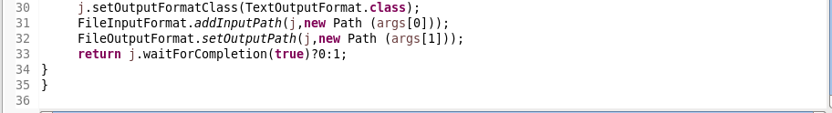

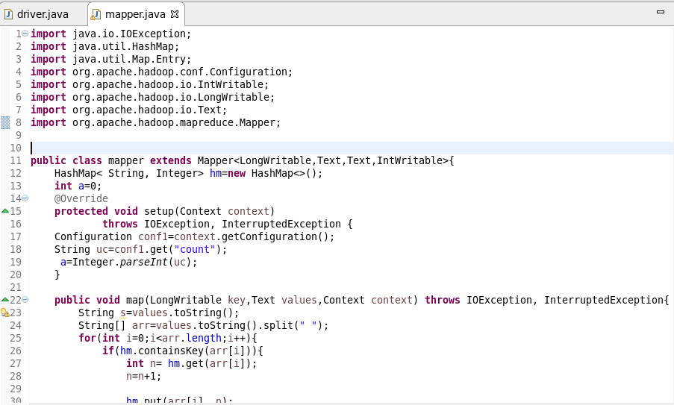

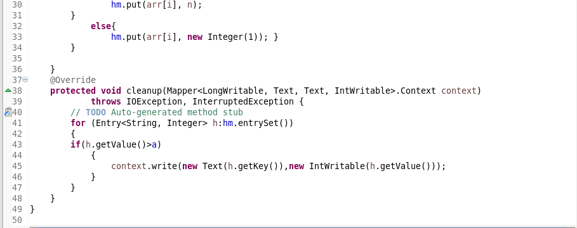

**Output:**

